TPE Takes New Step to Connect the Third Pole and Arctic

The 2019 Arctic Circle Assembly was held in Reykjavik, Iceland from October 9-12. Mr. Olafur Ragnar Grimsson, former president of Iceland and chairman of the Article Circle, met with Prof. YAO Tandong, co-chair of the Third Pole Environment (TPE). Prof. Yao introduced TPE’s latest developments and Mr. Grimsson suggested that TPE organize a session for the 2020 Global Eco Forum. The two, who have worked together for years to promote scientific collaboration between the two poles, agreed to expand the scope of TPE-Arctic Circle cooperation and outlined priorities for their partnership in 2020.

During the 2019 Arctic Circle Assembly, Prof. Yao presented a keynote plenary speech entitled “Third Pole Environment (TPE),” in which he introduced the international science program and highlighted the importance of scientific cooperation involving the Third Pole and the Arctic. “Connecting the Third Pole and the Arctic would allow for new perspectives on the global environment, where relations can be drawn between natural, economic, and social aspects,“ said Prof. Yao. Mr. Grimsson agreed.
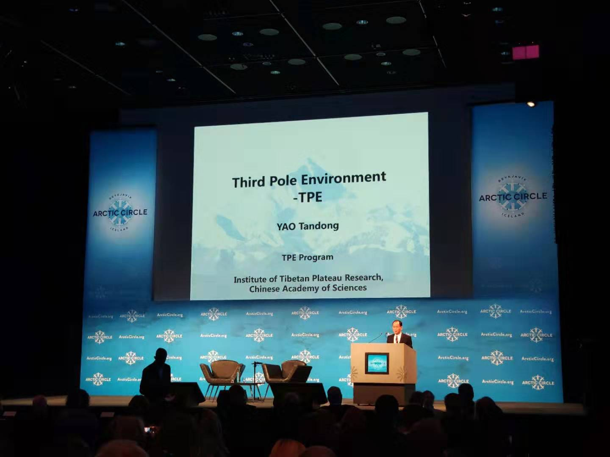
To highlight their joint effort, a session themed “Changing Cryosphere at the Third Pole and the Arctic” was held during the Assembly, attracting about 30 scientists from eight countries who came together to draw connections between the two regions. An ongoing cooperative project on the observation of stable water isotopes has attracted strong interest among the participants. Notably, TPE recently installed its first Arctic observation site at the University of Iceland, which allows scientists to monitor land-surface vapor in the Arctic region in real time. “This marks the beginning of coordinated Third Pole-Arctic research under TPE and paves the way for future cooperation on cryospheric studies,” said Prof. GAO Jing, a research scientist from the Institute of Tibetan Plateau Research, Chinese Academy of Sciences. Prof. Gao built the site with Dr. Arny Erla Sveinbjornsdottir, a research scientist from the University of Iceland, and Dr. Hans Christian Steen-Larsen, a research scientist from the University of Bergen.

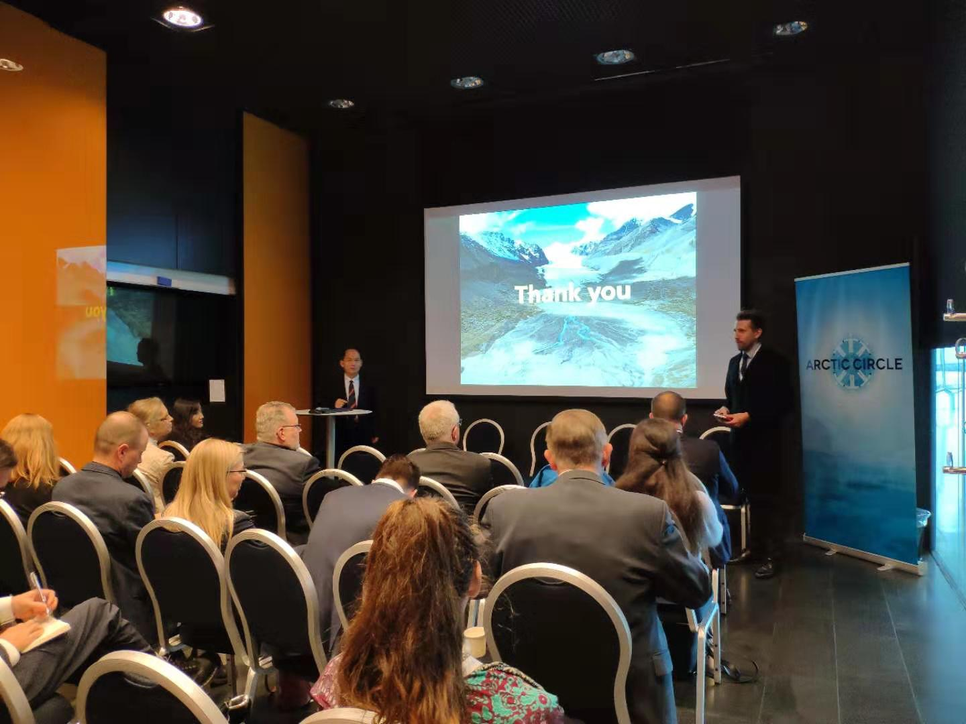

The Third Pole and the Arctic are both of overriding importance for the global climate and are both extremely sensitive to global environmental and climate change. The two regions experience strong interactions among air, land, sea and ice, which shape forces in the atmosphere and ocean. Populated by vast glaciers, the Third Pole and the Arctic are both vulnerable to rising temperature, which melts glaciers and disrupts the water cycle and ecosystems. Indigenous people in these regions are particularly exposed to threats to their lifestyle, livelihood and even their very survival. (Reported by XIA Cuihui)

